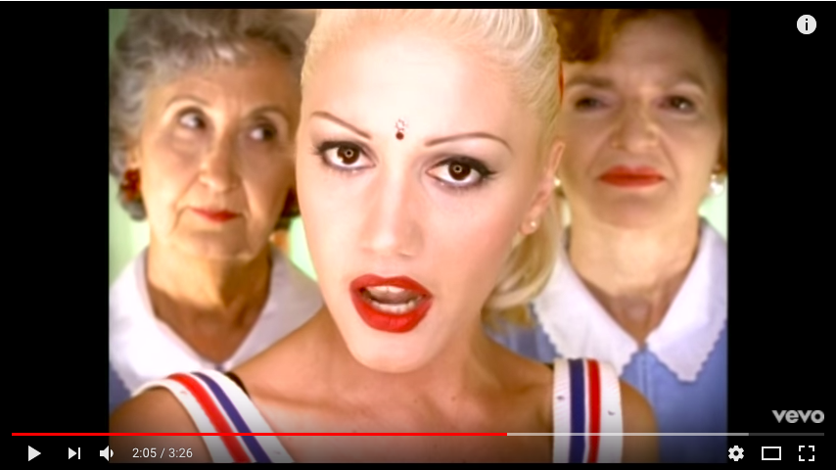
JUST A GIRL

1. Fill in the gaps with the words from the list

Take this pink ribbon off my eyes
I'm exposed
And it's no big ________________(1)
Don't you think I know
Exactly where I stand
This ____________ (2) is forcing me
To hold your _____________ (3)
hands rights world surprise run things
'Cause I'm just a girl, little ol' me
Well, don't let me out of your sight
Oh, I'm just a girl, all pretty and petite
So don't let me have any ____________ (4)
Oh, I've had it up to here!
The moment that I step outside
So many reasons
For me to ____________ (5) and hide
I can't do the little things
I hold so dear
'Cause it's all those little _____________ (6)
That I fear

2. Match the parts

1. 'Cause I'm just a girl  2. 'Cause they won't let me drive  3. Oh I'm just a girl  4. 'Cause they all sit and stare  5. Oh I'm just a girl  6. Just your typical prototype | a. With their eyes  b. Yes, I'm some kind of freak  c. Oh, I've had it up to here!  d. Take a good look at me  e. I'd rather not be  f. Late at night
3. Fill in the gaps with the words from the list
thumb captivity apology lucky destiny

Oh, am I making myself clear?
I'm just a girl
I'm just a girl in the world
That's all that you'll let me be!
Oh I'm just a girl, living in ______________ (1)
Your rule of _____________ (2)
Make me worry some
Oh I'm just a girl, what's my ____________ (3)?
What I've succumbed to
Is making me numb
Oh I'm just a girl, my ______________ (4)
What I've become is so burdensome
Oh I'm just a girl, _____________ (5) me
Twiddle-dum there's no comparison
Oh, I've had it up to!
Oh, I've had it up to!!
Oh, I've had it up to here

