EDGAR ALLAN POE
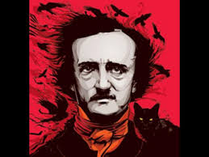
Nerdy and quirky: Who was Edgar Allan Poe really?
https://www.youtube.com/watch?v=iQOhM6c0-Lo

1. Why was Poe taken in by the Allan family?

- What two places did he drop out of?

- Under what pseudonym did Poe publish his firs book of poems? What was the book called?

- Why did Poe move to Baltimore?

- How did he make a living?

- When did he reach the peak of his fame?

- What did his wife die of?

8. How did Griswold portray Poe in his memoirs?

- Did Griswold's scheme to destroy Poe's reputation succeed?

10 . How many cities in the west coast of the USA are mentioned?

- What was so mysterious about Poe's death?

12. Which one of all the theories about his death is the most likely to be true?

