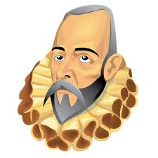
MIGUEL DE CERVANTES
Ask the appropriate questions to your partner to complete the ing information. Then write a biography of Cervantes. Include pictures.

Student A
Date of birth: 1547
Place of birth:
Father’s name: Don Rodrigo Cervantes.
Father’s job: surgeon.
Mother’s name:
1571: fights in battle of Lepanto and loses……………………
1572-1577: spends five years as a slave in ……………………..
The Trinitarians pay the ransom.
1585: marries Catalina Salazar.
moves to Seville to work as a tax collector.
publishes first pastoral novel, La…………………………
1597: goes to jail in………………………………………
……….: publishes Don Quixote.
1613: dies on April …………………

MIGUEL DE CERVANTES
Ask the appropriate questions to your partner to complete the missing information. Then write a biography of Cervantes. Include pictures.
Student B
Date of birth:
Place of birth: Alcala de Henares, Madrid
Father’s name:
Father’s job: surgeon.
Mother’s name: Dona Leonor de Cortinas
1571: fights in ……………………………………. and loses his left arm.
1572-1577: spends ………………years as a slave in Algiers.
The ………………………………………. pay the ransom.
1585: marries Catalina Salazar.
moves to……………………………to work as a tax collector.
publishes first pastoral novel, La Galatea.
1597: goes to jail in Seville
1605: publishes Don Quixote.
1613: dies on ……………………………..22nd.
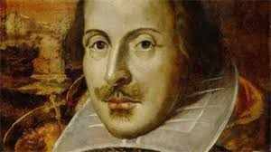
WILLIAM SHAKESPEARE

William Shakespeare was born in 1564 in Stratford-on-Avon, in the centre of England. When he was eighteen years old, he married Anne and they had a daughter the following year. Shakespeare became an actor and went to London. He started writing plays and by the age of thirty he was famous. In 1595 Anne had twins, a boy and a girl. The boy died at the age of eleven. Shakespeare spent the last four years of his life in Stratford and dies on April 23rd 1616, a day after the death of the famous Spanish writer Cervantes.
Although he is so famous, we know very little about his life. We know that he wrote 37 plays: tragedies like Romeo and Juliet or Hamlet; historical plays like Julius Caesar; and comedies like A Midsummer Night’s Dream or The Merchant of Venice. Most of his plays were performed at his famous theatre in London,The Globe. He also wrote many beautiful poems called sonnets.
The theatre was very important in Shakespeare’s time. There were no newspapers, magazines, cinemas or TV. Small theatre companies travelled all over the country to present plays in hotels called inns.

1.Read the text and answer the following questions in complete answers.
1.Where was Shakespeare born?

2.Who did he marry?
3. Did he have any children?
4. What did he write?
5. Why was the theatre important in his time?
6. What famous Spanish writer died a day before Shakespeare?

